Transition into our school, transition through our school, transition to a new school
Child’s name: |  |  | Date of birth:
Name of previous settings: |  |  | Full-time or Part-time. Number of hours _______
Information requested
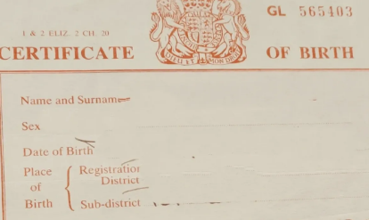 | Family members and extended family members  Families can go through many changes over time.  It is important that school has the details of all adults that are actively involved in your child’s life so we can build positive relationships that support the whole family effectively.
Parental response
Information to consider;
Adults in your child’s life and relationship
Adults who live in your house
Adults who will collect your child from school (family members, child minder, friend)
What are the arrangements for your child visiting another family member? (e.g. weekly, mid-week, alternate weekends arrangements)
At any point have your family been involved with social services, e.g. adoption?
Information requested
 | Health journey – birth to 4 years old  Current and historical medical information is extremely important and can impact on how your child learns, plays and forms relationships.  It is important that school has all relevant medical information.
Parental response
Information to consider;
Was your child premature?
Did your child require special care at birth?
Does your child require regular medication?
What is the dosage? Frequency required?
Do staff need any specific medical training?
Does your child have any special dietary requirements?
Does your child have any allergies?
Has your child had surgery or a hospital stay?
Have any referrals been made to the GP or community paediatrician?
Has your child had an eye test?
Information requested
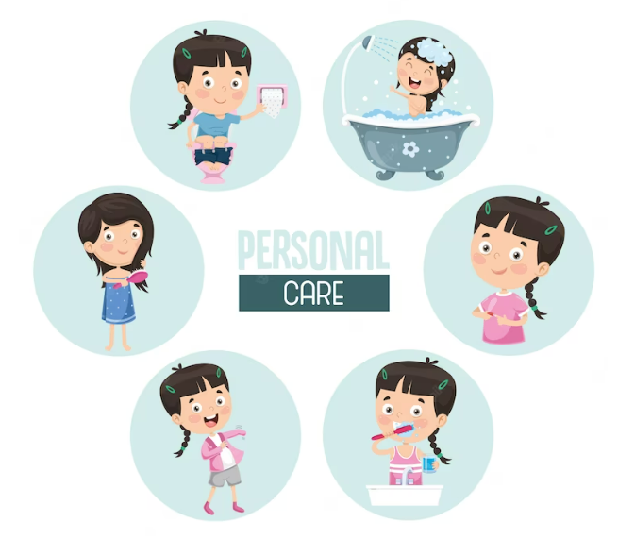 | Personal Care  Children gaining independence for their own personal needs is very important. However, if your child needs additional support from staff, advice and help can be given.
Parental response
Information to consider;
Does your child need support with toileting?
Do they wear pull-ups?
Are they receiving medical support from the GP or incontinent team?
Does your child require regular medication?
What is the dosage? Frequency required?
Can they dress/undress independently?
Can they use buttons and/or zips?
Can they hold and use cutlery correctly?

Information requested
 | Behaviour  Behaviour is a way of communicating needs or wants in response to an environment. Behaviour allows communication 'beyond words'. What we often don't realise is that when someone is 'acting out', screaming or aggressive in nature, they are trying to tell us something that is often difficult to communicate with speech. If you would like any additional support from staff, advice and help can be given.
Parental response
Information to consider;
Do you have concerns regarding your child’s behaviour?
What behaviours are displayed when they are dysregulated? (frequent intense temper tantrums and outbursts)
What ‘triggers’ the behaviours? (sensory overload – loud noises, busy environments, certain words and phrases, separation from parents.)
Is there a pattern to the behaviours?
Does your child manage transitions from room to room, between adults?
Is your child confident when coming into school?
What comforts your child when they are distressed?
Information requested
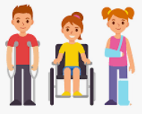 | Physical Needs  Current and historical medical information is extremely important and can impact on how your child learns, plays and forms relationships.  It is important that school has all relevant medical information.
Parental response
Information to consider;
Does your child need any additional equipment? (Wheelchair, walker, writing slope, cushion)
Has your child received support from a physiotherapist?
Has your child received support from an Occupational therapist?
Is your child able to hold a pencil correctly?
Is your child able to hold cutlery correctly?
Information requested
 | Communication  Communication skills are very important as they allow your child to express their ideas and feelings, giving people instructions and information.  If your child needs additional support from staff, further advice and help can be given.
Parental response
Information to consider:
What language does your child speak at home?
Does your child need access to communication aids? (PECS, Makaton, British Sign Language)
Does your child communicate through gestures?
Does your child use keywords and phrase when they talk?
Has your child received support through a Speech and Language therapists?
Staff Information
In addition to the experienced Early Years Reception Team, additional support is available through Mrs Elaine Ayton our Special Educational Needs Co-ordinator (SENCO) and Mrs Josephine Currell our Family Support Worker (FSW) All members of staff can be contacted by telephone, 01604 843780 through the school office.

